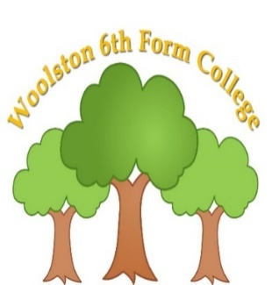 | 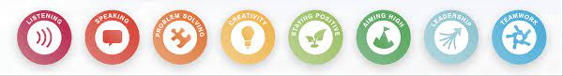  Learning for life Pathway - Form 5  Spring Term 2025  Curriculum Overview
Key Information
- Snack is £2 per week (Alternatively, £12 for the half term – 6 weeks/ £26 for the term), or snack can be sent in from home. Drinks of water will always be available.
- Fitness & Wellbeing sessions are on a Monday afternoon. Please could students wear suitable clothing.

Please read through the information below to find an overview of what your son/daughter will be learning about over the coming term until April 2025.
Functional English | Functional Maths | Careers/Employability | Preparation for Adulthood
Creating an interest: to explore books, including traditional tales. To learn about famous authors and different types of fiction/ non- fiction texts.  Sharing information: to learn about and experience different methods of communication, including letters, emails, post cards, texting and social media. Safety – when/ where it is appropriate to share information. | Financial responsibilities: money recognition and skills, household budgets, wants and needs.  Repeating patterns: experiencing, identifying and extending patterns in number, shape and letters. Problem solving.  Basic skills – addition, subtraction, multiplication, division. | What are employers looking for? Exploring skills and qualifications for different jobs/ careers as well as practising ‘Soft’ skills.  Rights and responsibilities of the employee/ employer.  Searching of jobs – internet, newspapers, library, job centre.  Developing a CV. | Road safety: to learn about and experience safe road crossing procedures, identification of hazards in accessing the community and recognising signs and symbols for road safety.  First aid and getting help: to learn about and experience basic first aid techniques and when/ where to access help.
Personal Development | Vocational | Creative | Fitness & Wellbeing
European culture: to learn about and experience European culture, lifestyle, arts, language, food, traditions.  Advocacy and self- expression: to learn about and experience advocacy for their wants, needs and aspirations; enhancing their self- expression and sharing opinions, alongside making informed choices. | 2025 options have now been chosen by students and will last until the end of the summer term.  Leisure & tourism  Horticulture  Hospitality  Business and Leisure  [Please see your child’s home/ college diary for their individual timetable choices] | Performing arts skills – to participate in and gain knowledge of different drama techniques. To explore emotions and characters through role play.  3D art – to experiment with different visual and tactile forms of 3D art, creating art pieces using different media (I.e. digital media, clay). | Relationship, Sexual and Health Education (RSHE): health and prevention. To explore ways to maintain a healthy lifestyle in relation to physical and mental health.  Sport in the community: to learn about and experience sport in the community. To explore health and leisure facilities in their local community.
Reading suggestions to enhance learning: traditional tales (E.g. Grimm’s fairy tales, Alice in Wonderland, Shakespeare) , personal information – full name/ DOB, address, career questionnaires/ surveys for students, recipes, health leaflets and websites, road signs and symbols.

Curriculum Skills at Home
Why not make time and use our curriculum skills to learn more at home?

Reading |  | English |  |  | Maths
Reading a favourite book  Reading/ following a recipe  Reading instructions for a microwave meal  Reading signs in the supermarket/ in the community/ road signs  Personal information – home address, DOB, phone number |  | Following instructions to complete a job for parents  Filling in an application form, with support  Talking to friends and family on the phone  Sending a text  IXL English |  |  | Counting money  Cooking/baking  Measuring  Timing meals/ scheduling their day  Looking for patterns and shapes in their environment
Preparation for Adulthood (related to EHCP Outcomes)

Cognition & Learning | Social, Emotional & Mental Health |  | Speech, Language & Communication | Sensory/Physical |  | Preparing for Adulthood
Writing and following a shopping list  Using money to pay for shopping  Using a bank card  Reading a timetable  Reading the opening times of a shop  Video/iPad games  Memory games  Card games | Going for a walk outside  Exercise  Listen to music  Chat to parents/ friends  Visit the Youth Zone/ Wolf club – social opportunities  Colouring/drawing  Meeting friends/family  Doing jobs around the house  Lego  Calming activities – guided meditation, deep breathing |  | Playing board games  Listening to sounds in the community  Using talkers/AAC regularly and appropriately  Simple discussions of topics of interests  Meeting friends and family socially  Phonic sounds – reading, rhymes, poems, jokes  Greeting people – requesting a drink/ food/ product in a shop or café | Bouncing on a trampoline/ gym ball  Balancing  Climbing stairs  Sensory stories  Star jumps  Crawling  Jumping  Baking  Trying new foods  Join a social group – community adventures  Water play  Fidgets and fine motor skills games |  | Putting washing away  Hanging out the washing  Doing the dishes  Cleaning/ hoovering  Taking a dog for a walk  Going shopping with a list to follow  Tidying their bedroom  Making breakfast before college/ helping with family meals  Putting the dishwasher on  Taking care of pets  Telling the time – recognising times of the day and relevant activities

