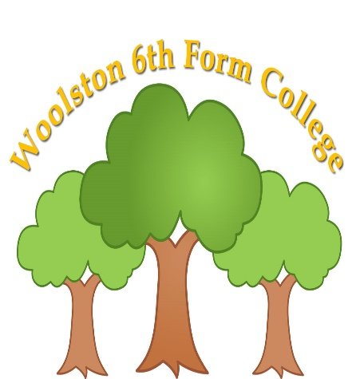 | Skills for Supported Living Pathway Form 2 Summer Term 2025  Curriculum Overview
 | 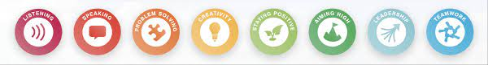
Key Information
- Snack is £2 per week (Alternatively, £10 for the half term – 5 weeks), or snack can be sent in from home. Drinks of water will always be available.
- The students have the opportunity to take part in internal work experience. Office jobs such as photocopying, shredding and recycling. Kitchen job such as emptying and loading the dish washer, sorting out the washing and cooking cakes and puddings for the student’s dinners.
- Form to engage in enterprise, which is sausage butties and car washing.
- Fitness & Wellbeing sessions are now on a Monday afternoon. This term the students have a chance to participate in sessions from the Youth in mind Team from Warrington Youth Zone.

Please read through the information below to find an overview of what your son/daughter will be learning about over the coming term until July 2025.
Functional English | Functional Maths | Careers/Employability | Preparation for Adulthood
Literacy for Life and Leisure - Using Leisure Facilities: The students will take part in selection of leisure activities, practicing their speaking and listening skills, social skills and working together as a team. They will also follow a range of verbal and visual instructions for a range of activities.  Literacy in the Future  Consolidation of This is Me and Personal Statements OR units: To recap on work completed at the beginning of the college year, looking at whether their targets have been achieved, and if their strengths and weaknesses have developed or changed. | Shape, colour and space: Students will look at a different shapes, recongising shapes within the environment, sorting shapes by size, shape and colour. They will also create simple repeating patterns using different shapes and colours.  Maps, travel and timetables: The student will look at different positional language and directional language focusing on forwards and back. Students will look at basic maps and complete activities using pictorial maps to travel around the college site. | Career Planning: This term student’s will look at skills that they have for different jobs and how they can improve and develop on their skills to fit jobs they are interested in.  Internal Work experience: -  Supporting the cook in the kitchen and carrying out administration work in the college office, such as shredding and photocopying. | Community Project: The students will look at different community projects that they could take part in. They will then complete a community project working with the rangers in Woolston park, completing a range of jobs within the park.  A Job Study: The students will look at selection of jobs that they might be interested in. They will choose a job to look at, and then they will look at the skills needed for that job. Practise the different skills, developing and improving on them over the half term.  Life skills: Making a simple snack, washing the dishes and setting the table.
Personal Development | Vocational | Creative | Fitness & Wellbeing
Friends and Family: To look at what makes a good friend, what they would like from a friend. Look at their family and who is important to them at home and why.  Democracy – Rights and Responsibilities: The student’s will look at what democracy is. They will look at the simple rights and responsibilities that they have and how they can achieve these | Horticulture: The students will take part in different horticulture activities such as planting, weeding and taking care of plants, both within class and out in the horticulture area.  They will focus on ‘what plants need to grow’ and the parts and functions of plants. | Music – To explore different musical instruments, the sounds they make. Look at which instruments and sounds they like and why. To listen to and being to recognise simple vocal related to sound and music.  Performing Arts – The student’s will practise basic performing arts skills, Expressing feelings with facial expressions and body movements. Recreating simple stories and events that they have experienced. | Flexible learning – Physical Wellbeing: The students will look at social stories about going to different health care professionals e.g. doctors, dentist, opticians. They learn about what to expect when they visit these places and equipment that might be used.  Physical Health – Team Sports: The student’s will take part in a range of team sports within college, Bocca, rounder’s etc. They will practise the skills required to take part in team sports, turn taking supporting one another etc.

Curriculum Skills at Home

Why not make time and use our curriculum skills to learn more at home?

Reading |  | English |  |  | Maths
Reading a favourite book  Reading a recipe  How to cook a tin of soup/beans  Reading a microwave meal  Reading signs in the supermarket  Reading road signs |  | Following verbal instructions to complete a job for parents  Following directions  Talking to friends and family  Sending a text |  |  | Setting the oven  Setting the microwave  TV guide  Counting money  Cooking/baking  Measuring liquids
Preparation for Adulthood (related to EHCP Outcomes)

Cognition & Learning | Social, Emotional & Mental Health |  | Speech, Language & Communication | Sensory/Physical |  | Preparing for Adulthood
Looking at a magazine  Helping to write a shopping list  Using money to pay for shopping  Using a bank card  Reading the opening times of a shop  Setting the washing machine  Video/iPad games  Memory games  Social activities | Going for a walk in the fresh air  Exercise  Listen to music  Chat to parents  Go outside  Visit the Youth Zone  Visit the Wolf club  Colouring/drawing  Meeting friends/family  Doing jobs around the house  Lego  Calming activities |  | Playing board games  I spy  Card games  Listening to sounds in the community  Using talkers/AAC  Simple discussions of topics of interests  Playing games with family members  Meeting friends and family | Bouncing on a trampoline  Balancing  Climbing stairs  Sensory stories  Star jumps  Crawling  Jumping  Baking  Eating cereal  Bubbles  Playdough  Collecting leaves and other nature items |  | Putting washing away  Hanging out the washing  Doing the dishes  Cleaning  Taking a dog for a walk  Shopping in the supermarket  Tidying the bedroom  Making breakfast before college  Putting the dishwasher on  Taking care of pets

