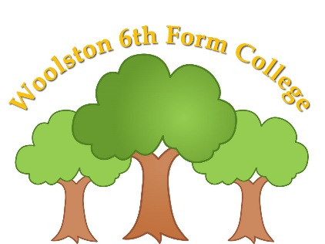

Woolston 6th Form College
Woolston Learning Village
Holes Lane
Woolston
Warrington
WA1 4LS

Tel: 01925 811447
Fax: 01925 852435
Email: woolstonsixthformcollege@sch.warrington.gov.uk

TERM DATES – 2024/2025

Terms | Date of Opening | Date of Closing
2024
Autumn 1 | Wednesday 4th September | Friday 18th October
Autumn 2 | Monday 28th October | Friday 20th December
2025
Spring 1 | Wednesday 8th January | Friday 14th February
Spring 2 | Monday 24th February | Thursday 3rd April
Summer 1 | Wednesday 23rd April | Friday 23rd May
Summer 2 | Monday 2nd June | Friday 18th July

Good Friday – Friday 18th April, 2025
Easter Monday – Monday 21st April 2025
May Day Holiday – Monday 5th May 2025

Teacher Training Days
Monday 2nd September 2024
Tuesday 3rd September 2024 College only
Monday 6th January 2025
Tuesday 7th January 2025 College only
Friday 4th April 2025
Tuesday 22nd April 2025 College only
Monday 21st July 2025
Tuesday 22nd July 2025

