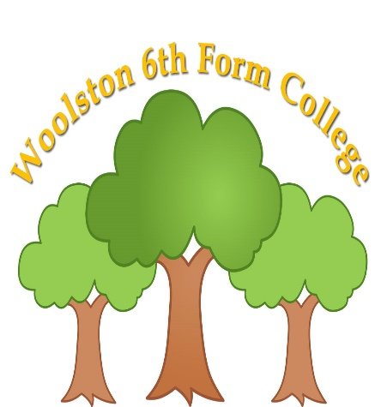 | Skills for Supported Living Pathway Form 2 Spring Term 2025  Curriculum Overview
 | 
Key Information
- Snack is £2 per week (Alternatively, £12 for the half term – 6 weeks/ £26 for the term), or snack can be sent in from home. Drinks of water will always be available.
- Work experience Both internal and external placements – various opportunities at different times
- We make sausage butties on a Thursday morning as part of our enterprise and functional skills work
- Fitness & Wellbeing sessions are on a Monday afternoon.

Please read through the information below to find an overview of what your son/daughter will be learning about over the coming term until April 2025.
Functional English | Functional Maths | Careers/Employability | Preparation for Adulthood
Creating an interest: To explore books mainly traditional tales. Exploring the common elements such as a magical setting, talking animals, good and evil characters and a happy ending.  Sharing Information – Letters and Postcards: To look at range of letters and postcards, what the features of these, how they are different and the different uses of letters. Use preferred methods of communication to answer questions about the letters and postcards they look at. | Numbers: Basic skills – recognising, counting, sequencing simple addition and subtraction.  Using Numbers: Basic skills – recognising, counting, sequencing simple addition and subtraction. Recognising numbers both within college and out in the community.  Enterprise – continue to make and sell sausage butties on a Thursday morning as part of this  Work | Exploring the World of Work: This term the students will be identifying the different jobs roles within college and looking at the people who help us out in the community.  Internal Work experience: - Maintenance work with the caretaker.  Supporting the cook in the kitchen and carrying out administration work in the college office | Road safety: The students will explore road safety signs, participate in crossing the road safely and identify common hazards when out in the community.  First aid and Getting Help: Student’s will look at people who can help them and what different situations they can help them in. They will also look at the different ways that they can communicate that they need help.  Life skills: Making a simple snack, washing the dishes and setting the table.
Personal Development | Vocational | Creative | Fitness & Wellbeing
European culture: To explore about and experience European culture, lifestyle, arts, language, food and traditions.  Advocacy and Self-Expression: The student’s will look at different emotions and how these emotions might be expressed. They will also look at how they can make choices and use their preferred method of communication to make choices. | Design and build: The students will explore ideas for items to be made for valentine’s day. They will also incorporate making small gift gestures for our friends which is the term topic in fitness and wellbeing.  Horticulture: The students will take part in different horticulture activities such as planting, weeding and taking care of plants, both within class and out in the horticulture area on the back field. | Performing arts skills – To explore and participate in different drama techniques.  To explore emotions and characters through role play. Cross curriculum with functional English and traditional tales.  3D art – The student’s will be looking at different types of art and then will use different materials to create their own pieces of 3D art. | Relationship, Sexual and Health Education (RSHE): To explore different relationships such as friendships, family and extended family members, appropriate and in appropriate.  Changes within our bodies, public and private.  Physical Health: The student’s will look at different ways that they can stay healthy and then take part in a range of appropriate physical activities within college, such as using the outdoor gym and walking round the daily mile track.

Curriculum Skills at Home

Why not make time and use our curriculum skills to learn more at home?

Reading |  | English |  |  | Maths
Reading a favourite book  Reading a recipe  How to cook a tin of soup/beans  Reading a microwave meal  Reading signs in the supermarket  Reading road signs |  | Following verbal instructions to complete a job for parents  Following directions  Talking to friends and family  Sending a text |  |  | Setting the oven  Setting the microwave  TV guide  Counting money  Cooking/baking  Measuring liquids
Preparation for Adulthood (related to EHCP Outcomes)

Cognition & Learning | Social, Emotional & Mental Health |  | Speech, Language & Communication | Sensory/Physical |  | Preparing for Adulthood
Looking at a magazine  Helping to write a shopping list  Using money to pay for shopping  Using a bank card  Reading the opening times of a shop  Setting the washing machine  Video/iPad games  Memory games  Social activities | Going for a walk in the fresh air  Exercise  Listen to music  Chat to parents  Go outside  Visit the Youth Zone  Visit the Wolf club  Colouring/drawing  Meeting friends/family  Doing jobs around the house  Lego  Calming activities |  | Playing board games  I spy  Card games  Listening to sounds in the community  Using talkers/AAC  Simple discussions of topics of interests  Playing games with family members  Meeting friends and family | Bouncing on a trampoline  Balancing  Climbing stairs  Sensory stories  Star jumps  Crawling  Jumping  Baking  Eating cereal  Bubbles  Playdough  Collecting leaves and other nature items |  | Putting washing away  Hanging out the washing  Doing the dishes  Cleaning  Taking a dog for a walk  Shopping in the supermarket  Tidying the bedroom  Making breakfast before college  Putting the dishwasher on  Taking care of pets

