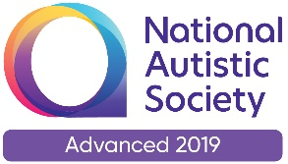           |   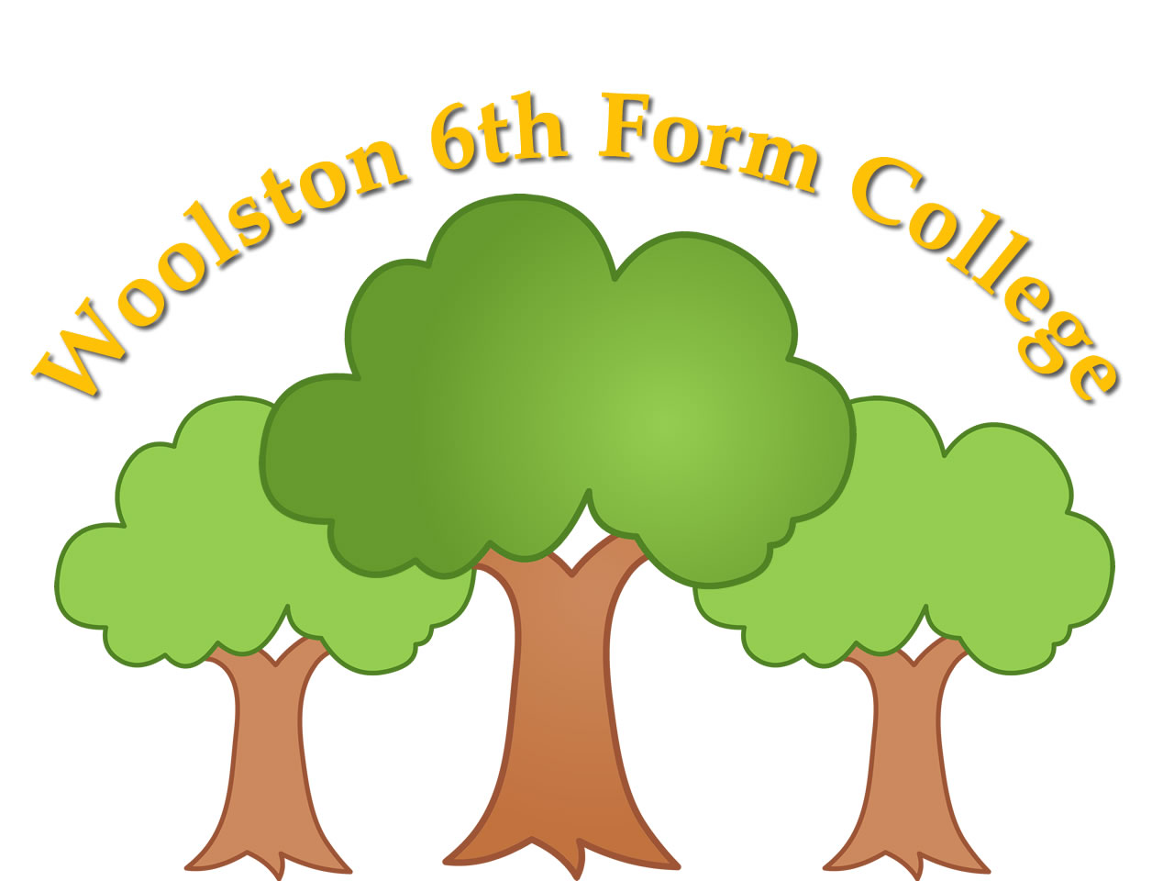  Woolston 6th Form College  Woolston Learning Village  Holes Lane  Woolston  Warrington  WA1 4LS  Tel: 01925 811447  Fax: 01925 852435  Email: woolstonsixthformcollege@sch.warrington.gov.uk

TERM DATES – 2025/2026

Terms | Date of Opening | Date of Closing
2025
Autumn 1 | Thursday 4th September | Friday 24th October
Autumn 2 | Monday 3rd November | Thursday 18th December
2026
Spring 1 | Wednesday 7th January | Friday 13th February
Spring 2 | Monday 23rd February | Wednesday 1st April
Summer 1 | Tuesday 21st April | Friday 22nd May
Summer 2 | Monday 1st June | Tuesday 21st July

Teacher Training Days  Tuesday 2nd September, 2025  Wednesday 3rd September, 2025  Friday 19th December, 2025 – College only  Monday 5th January, 2026  Tuesday 6th January, 2026 – College only  Thursday 2nd April, 2026  Monday 20th April, 2026 – College only  Wednesday 22nd July, 2026 | Bank Holidays  Good Friday – Friday 3rd April, 2026  Easter Monday – Monday 6th April, 2026  May Day Holiday – Monday 4th May, 2026

