WOOLSTON 6TH FORM COLLEGE  PARENTAL AGREEMENT FOR COLLEGE TO ADMINISTER MEDICINE | 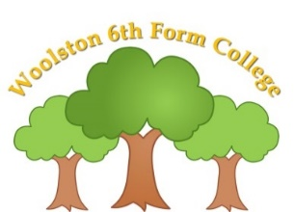
The college will not give your son / daughter medicine unless you complete and sign this form, and the college has a policy that staff can administer medicine when trained to do so.
Individual medication sheets to be completed for every medication to be administered.
Name of College | WOOLSTON 6TH FORM COLLEGE
Name of Student
Date of Birth
Form
Medical condition or illness

Symptoms to look out for

Any allergies?
Medicine
Name/type of medicine
(as described on container)
Date dispensed
Expiry date
Dosage and method ie, syringe, spoon, in a drink
Timing
Special precautions
Are there any side effects that the college needs to know about?
Contact Details
Name
Daytime telephone number
Relationship to Student
Signature: | Date:
I understand that the medicine must be delivered to college by myself or a named responsible adult.
I accept that this is a service that the college is not obliged to undertake. I understand that I must notify the college of any changes in writing.
Asthma treatment only

I consent to school using a spare salbutamol inhaler in the event of an emergency

Date: ………………………………… Signature: ………………………………………

NAME………………………………………………………………
Date/Time:
Dose given:
Tablets Remaining:
Staff initials:

Date/Time:
Dose given:
Tablets Remaining:
Staff initials:

Date/Time:
Dose given:
Tablets Remaining:
Staff initials:

Date/Time:
Dose given:
Tablets Remaining:
Staff initials:

Date/Time:
Dose given:
Tablets Remaining:
Staff initials:

Date/Time:
Dose given:
Tablets Remaining:
Staff initials:

