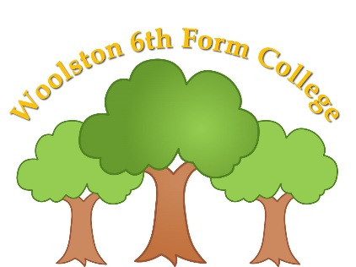

Woolston 6th Form College
Woolston Learning Village
Holes Lane
Woolston
Warrington
WA1 4LS

Tel: 01925 811447
Fax: 01925 852435
Email: woolstonsixthformcollege@sch.warrington.gov.uk

TERM DATES – 2023/2024

Terms | Date of Opening | Date of Closing
2023
Autumn 1 | Wednesday 6th September | Friday 27th October
Autumn 2 | Monday 6th November | Wednesday 20th December
2024
Spring 1 | Thursday 4th January | Friday 9th February
Spring 2 | Monday 19th February | Thursday 28th March
Summer 1 | Wednesday 17th April | Friday 24th May
Summer 2 | Monday 3rd June | Wednesday 17th July

Good Friday – Friday 29th March, 2024
Easter Monday – Monday 1st April, 2024
May Day Holiday – Monday 6th May, 2024

Teacher Training Days
Monday 4th September, 2023
Tuesday 5th September, 2023 (College only)
Thursday 21st December, 2023 (College only)
Wednesday 3rd January, 2024
Monday 15th April, 2024
Tuesday 16th April, 2024 (College only)
Thursday 18th July, 2024
Friday 19th July, 2024

