Personal Development Curriculum at Woolston 6th Form College.

In order to ensure coverage is appropriate and meets the needs of our learners we have built our curriculum around the outcomes from the PSHE Association SEND framework for KS4. These outcomes have been adapted from the KS4 national Curriculum and therefore meet statutory teaching requirements. Further information around the framework can be found below.
PSHE curriculum and outcomes:

The PSHE curriculum area and adapted outcomes are taken from the PSHE Association’s PSHE framework for SEND. This framework is fully aligned with the DfEs statutory guidance for PSHE which has adapted learning outcomes to ensure it is accessible for young people with SEND. Learning outcomes are mapped progressively and adapted for the levels and abilities at Woolston 6th Form students, rather than key stages, as below:
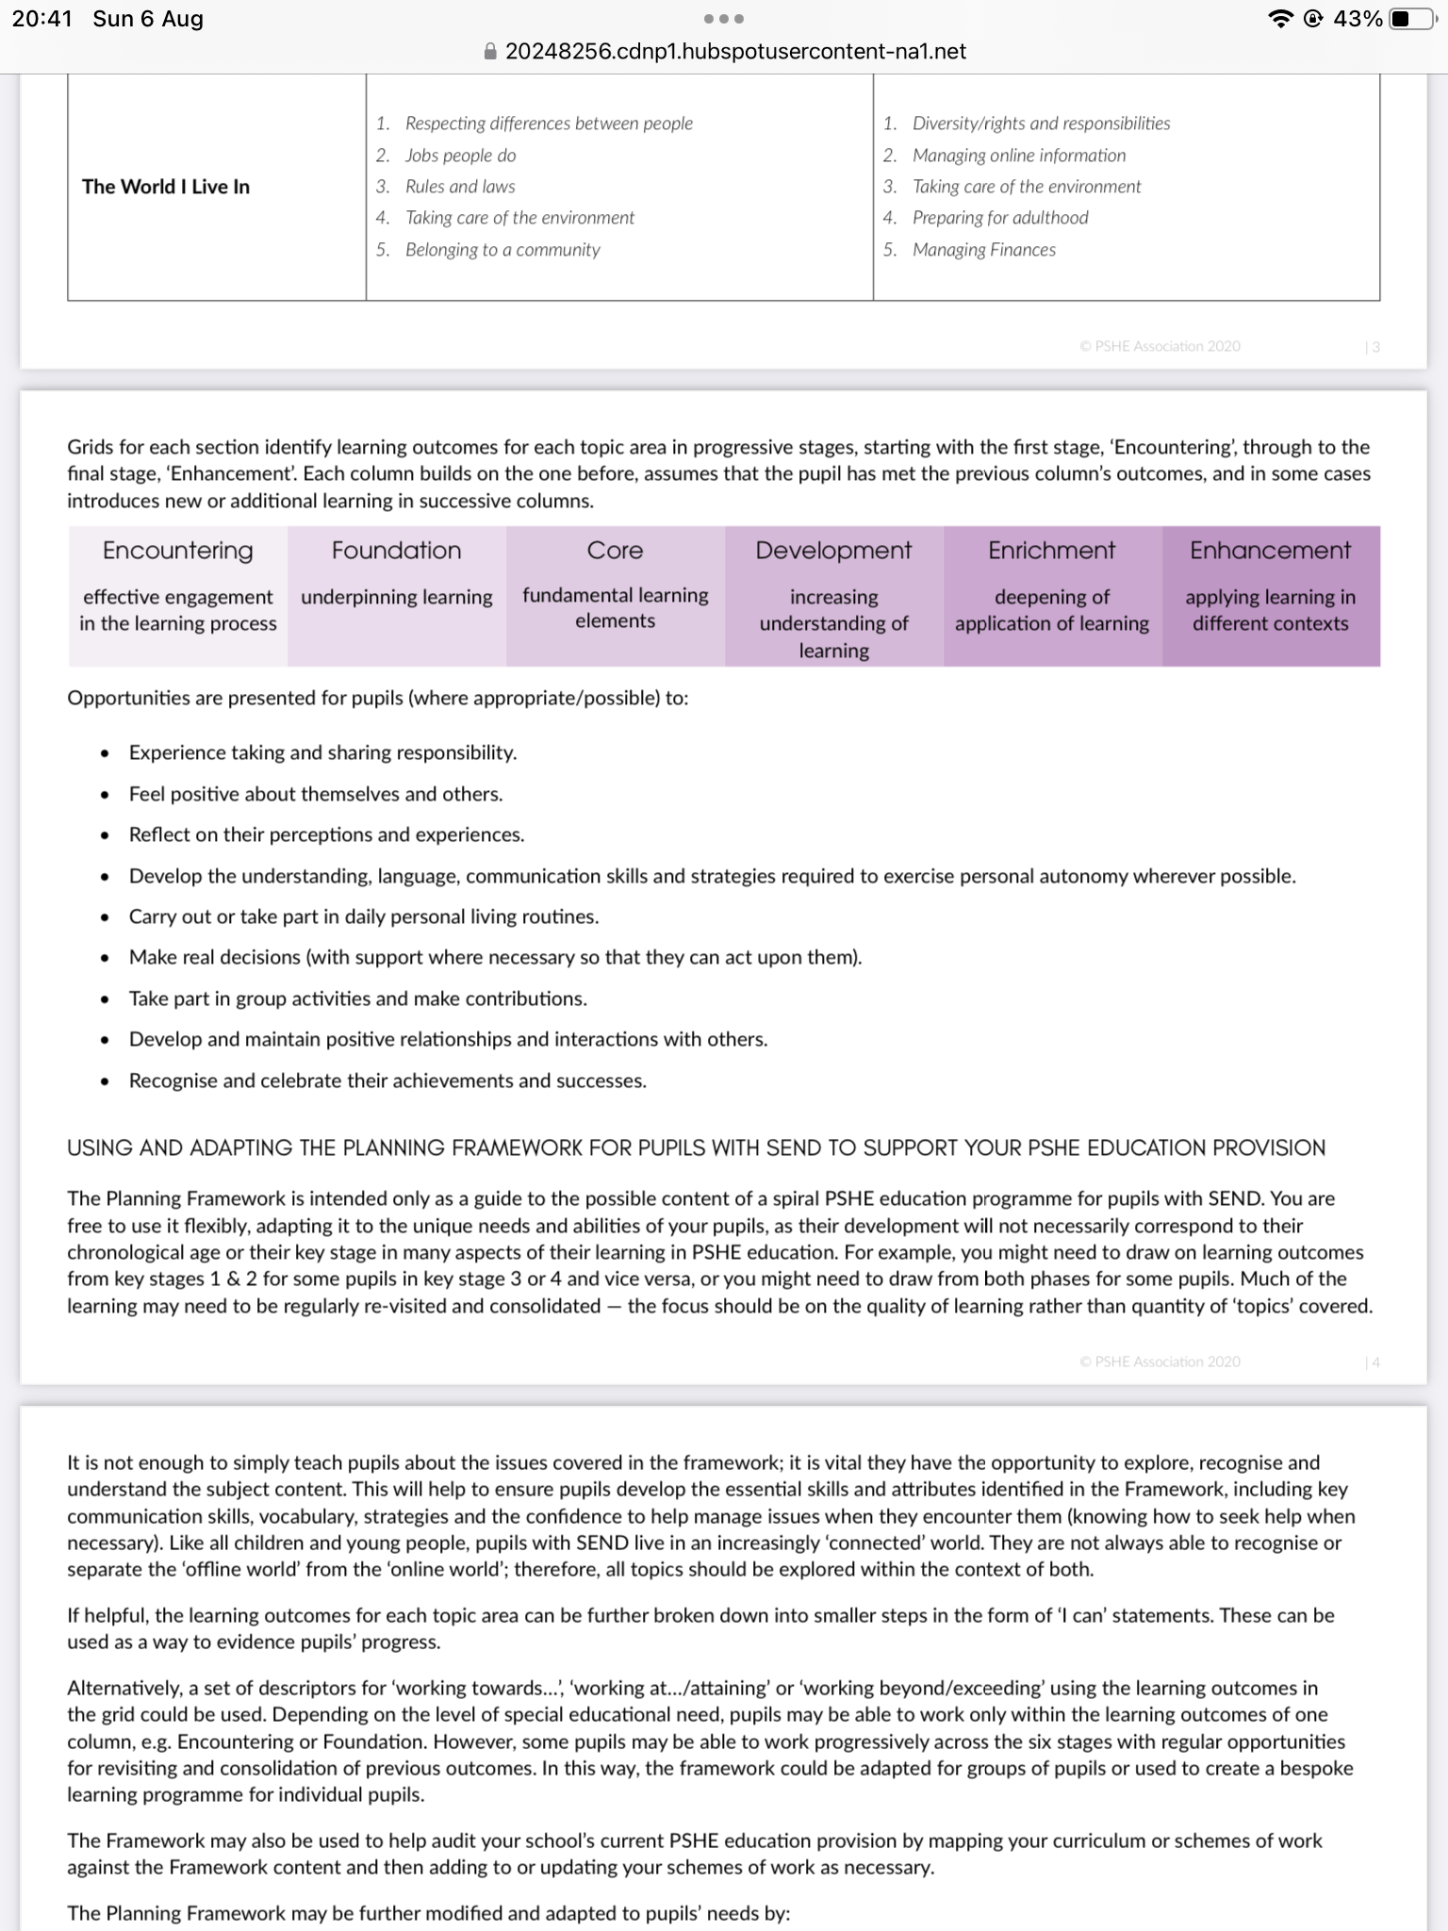

Sensory | Pre- entry | Entry 1 | Entry 2 | Entry 3 | Level 1
Equivalent levels adapted to Adult Curriculum assessments at Woolston 6th Form College

For each unit you must look across the stages and use appropriate outcomes pitched at the level of the students in your group. These outcomes should be clear in your MTP for PD. Please, take the outcomes from KS3-4 not KS1-2.

Within each year, planning will include activities to acknowledge (As appropriate):

January – Holocaust memorial day
February - Children’s mental health week, Safer internet day, Time to talk day
March – Comic relief/ red nose day, International day of happiness, International day for the elimination of racial discrimination day (We are all different)
April – World health day
May – Mental health awareness week, World fair trade day
June – Child safety week, Water safety week (Water hazards and dangers), World environment day
September – International day of charity, Fairtrade fortnight, International day of democracy
October – National hygiene week, World mental health day
November – Anti- bullying week, Road safety week, Remembrance Day, Day of the dead (Oct- Nov), Talk money week, Bonfire night (Safety, hazards etc), UK Parliament week, Children in Need
December – Christmas jumper day (NSPCC), Human rights day

Personal Development Curriculum - Woolston 6th Form College
3 Year plan.

Year 1: |  | Autumn | Spring | Summer
PSHE Curriculum area and adapted outcomes | First half term | Healthy Lifestyles: Personal Care and Hygiene | World we Live in: European Culture | Changing and Growing: Family and Friends
 |  | SA4, MF1, CH1, HL1, HL5 | SA3, WILI1 | MF1, MF2, MF3, CG2, CG3, CG4, CG5
Equals Curriculum |  | (Adventurer – Independent living) | (Adventurer – World Studies) | (Explorer – Independent living)
PSHE Curriculum area and adapted outcomes | Second half term | Self-Care & Safety: Staying Safe in the workplace | Self-awareness & managing feelings: Advocacy and self-expression | World we Live in: Democracy: Rights and Responsibilities
 |  | SA4, SSS2, SSS3, SSS5, WILI1, WILI4 | SA4, SSS2, SSS6, MF1, CG2, CG3 | SA3, SA4, SSS2l SSS6, CG3, CG4, HL7, WILI1, SA3, WILI1
Equals Curriculum |  | (Globetrotters - Vocational) | (Voyager – Independent living) | (Globetrotter - Independent living)

Year 2: |  | Autumn | Spring | Summer
PSHE Curriculum area and adapted outcomes | First half term | Self-Awareness & Managing Feelings: Emotions | The World I Live in: UK Culture | Healthy Lifestyles: Personal Care and Presentation (Employability)
 |  | SSS2, MF1, MF2, MF3, CG2, CG3, CG4, CG5 | SA3, WILI1 | SA1, MF1, CG2, HL2, HL5
Equals Curriculum |  | (Traveller – Independent living) | (Globetrotter – World studies) | (Globetrotter – Independent living)
PSHE Curriculum area and adapted outcomes | Second half term | Self-Care & safety: Exploitation | The World I Live In: Local Events | Changing and Growing/ RSHE: Body Awareness and Physical Changes
 |  | MF1, MF2, MF3, CG2, CG3, CG4, CG5 | WILI3 | SSS6, MF3, CG1, CG5, HL1, HL5
Equals Curriculum |  | Relationships  (Traveller – Independent living) | Local community events  (Globetrotter - World studies) | (Explorer – Independent Living)

Year 3: |  | Autumn | Spring | Summer
PSHE Curriculum area and adapted outcomes | First half term | The World I Live In: The Economy, Finance and Money | Healthy Lifestyles: Eating out | Changing and growing/ RSHE: Dealing with emergencies
 |  | HL1, HL2, WILI1, WILI4, WILI5 | HL4, WILI4, WILI5 | SSS1, SSS3, SSS5, HL2, HL6, HL7
Equals Curriculum |  | Economic Well-Being  (Voyager – Vocational studies) | (Voyager – Independent living) | (Voyager – Vocational studies)
PSHE Curriculum area and adapted outcomes | Second half term | The World I Live In: Religions, worship and festivals  (SMSC) | Self- care & safety/ RSHE: Online Safety | The World I Live In: Clothing care and maintenance
 |  | SA3, WILI1 | SA4, SSS2, SSS4, SSS7, MF1, CG3, HL2, WILI2 | WILI4, WILI5
Equals Curriculum |  | (Explorer – World Studies) | Personal Safety (Voyager – Independent living) | (Globetrotter - Independent living)

