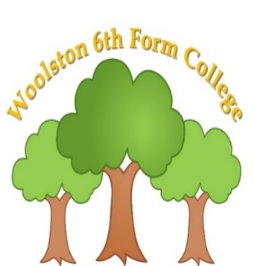 | 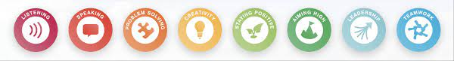  Learning for life Pathway - Form 5  Autumn Term 2024  Curriculum Overview
Key Information
- Snack is £2 per week, or snack can be sent in from home. Drinks of water will always be available.
- Fitness & Wellbeing sessions are on a Monday afternoon. Please could students wear suitable clothing.

Please read through the information below to find an overview of what your son/daughter will be learning about over the coming term until December 2025.
Functional English | Functional Maths | Careers/Employability | Preparation for Adulthood
Literacy in the Future – This is me and personal statements: reviewing skills and knowledge, then setting targets for the term/ year, autobiographies.  Literacy for Information – Magazines and Newspapers: the world around us, non- fiction texts. | Enterprise – business roles and responsibilities, money skills, teamwork.  Work – continuing our business enterprise project and enhancing with time skills and measure. | Jobs and careers – what do we want to do in the future?  Strengths and things to improve (Employability).  Skills and qualities for the workplace  Health and safety at work.  Researching jobs, specific skills needed and wages/ salaries. | CEIAG: Person Centred Planning – My future.  Daily living skills: Preparing a meal – Independent living skills.
Personal Development | Vocational | Creative | Fitness & Wellbeing
Healthy lifestyles: personal care and hygiene.  Self-care and safety- Staying safe in the workplace. | Across the autumn term, students will have 3 week ‘Taster’ sessions, to make informed choices on their preferred course for the spring and summer term. Options booklets will be sent out prior to Christmas break.  2024/ 25 options chosen by students (July 2024):  Leisure & tourism  Horticulture  Hospitality  Business and Leisure | 2D Art – we are researching and creating art pieces based on: Van Gogh (Oil pastels), Matisse (Collage) & Pollock (Paint and drip technique).  Making music – instruments, sounds, layering, beat, tempo, volume/ pitch. | Healthy lifestyles - Drug awareness.  Flexible learning – this enables us to deliver a bespoke unit of work based around the physical, mental and emotional needs of our Form 5 students. It will centre around wellbeing and relationships.
Reading suggestions to enhance learning: Magazines, newspapers, product advertisement posters/ online posts/ adverts on the TV, personal information – full name/ DOB, address, career questionnaires/ surveys for students, recipes.

Curriculum Skills at Home
Why not make time and use our curriculum skills to learn more at home?

Reading |  | English |  |  | Maths
Reading a favourite book  Reading/ following a recipe  Reading instructions for a microwave meal  Reading signs in the supermarket/ in the community/ road signs  Personal information – home address |  | Following instructions to complete a job for parents  Following directions  Talking to friends and family on the phone  Sending a text  IXL English |  |  | Setting the oven/ microwave  TV guide  Counting money  Cooking/baking  Measuring  Timing meals/ scheduling their day
Preparation for Adulthood (related to EHCP Outcomes)

Cognition & Learning | Social, Emotional & Mental Health |  | Speech, Language & Communication | Sensory/Physical |  | Preparing for Adulthood
Writing and following a shopping list  Using money to pay for shopping  Using a bank card  Reading a timetable  Reading the opening times of a shop  Video/iPad games  Memory games | Going for a walk outside  Exercise  Listen to music  Chat to parents/ friends  Visit the Youth Zone/ Wolf club – social opportunities  Colouring/drawing  Meeting friends/family  Doing jobs around the house  Lego  Calming activities – guided meditation, deep breathing |  | Playing board games  I spy  Card games  Listening to sounds in the community  Using talkers/AAC regularly and appropriately  Simple discussions of topics of interests  Meeting friends and family socially  Phonic sounds – reading  Greeting people – requesting a drink/ food/ product in a shop or café | Bouncing on a trampoline/ gym ball  Balancing  Climbing stairs  Sensory stories  Star jumps  Crawling  Jumping  Baking  Trying new foods  Bubbles  Playdough  Collecting leaves and other nature items  Join a social group – community adventures  Water play |  | Putting washing away  Hanging out the washing  Doing the dishes  Cleaning/ hoovering  Taking a dog for a walk  Going shopping with a list to follow  Tidying their bedroom  Making breakfast before college/ helping with family meals  Putting the dishwasher on  Taking care of pets  Telling the time – recognising times of the day and relevant activities

